

**USER GUIDE**

**STEP 2:**

**LOGIN**

So here you are. Ready for an adventure of your own. You have your computer ready? Is it plugged in? Better do that first. Once it is turned on, insert the flash drive into the USB slot. That is right just like that. Now, double click the little lemon that says DRINK-O-INSTALL below it. Yes, that one. Now click continue a few times and you are ready to go. (If you do not see the icon on your desktop go into programs and select it there. You may need to create a shortcut. You can find how to this buy going here: http://windows.microsoft.com/en-)us/windows/create-delete-shortcut#1TC=windows-7).

In the purchase information email you received your login and password. Find your user name and password. On the login screen enter your user name and password. Remember they are case sensitive. See screenshot below:

**STEP 1:**

**SET UP**

**INTRODUCTION**

Drink-O-Matic is your new assistant in being the best host, bartender, friend, drinking buddy or even just look like the know it all you possibly can. With the few steps below you can be on your way to a brilliant career in throwing parties an d living the high life.

**Welcome**

Welcome to the wonderful world of Drink-O-Matic. You have taken the first step in becoming a better person. IN this journey I will take you on, you will learn how to use you mouse to select a drink, ingredient or category. How to type in a name of a drink. If you feel up to you up to it I will walk you through adding your own drinks.

So made it this far. Exciting isn’t it? Tonight is that big dinner party and want to add new drinks in for the theme of the party. Sure everyone will enjoy your cocktail of unheard of liquors and frozen Kool-Aid. See the little button that says ADD NEW. Yes that one. Click it. There you go. On this new wonderful screen you can select up to 4 ingredients, the category and input the directions of that great new drink. See Screenshot below:

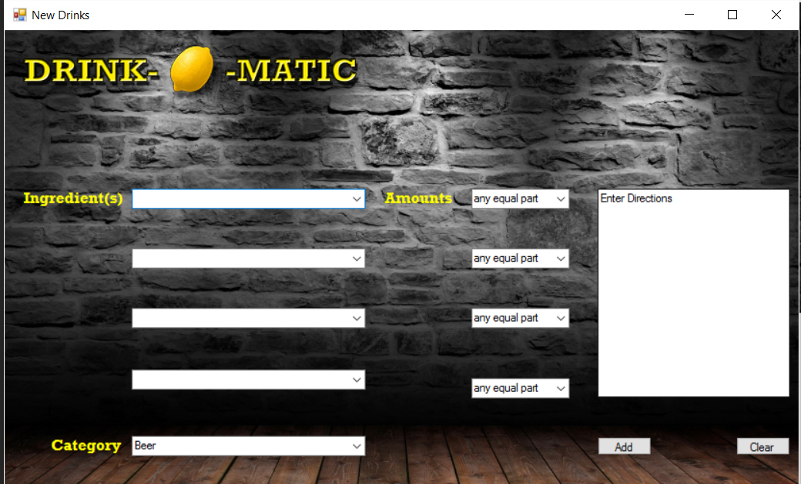

**STEP 5**

**ADD NEW DRINK**

Congratulations. You are in. You made it. You deserve a drink. But what drink you ask? Why not search for one, right?

Now you can search for what drink you want based on what kind of drink you want, what is in and or the name itself. Each drop down box show you what you can search for. Each box will display with the new information when you click a new drink. See screenshot below.

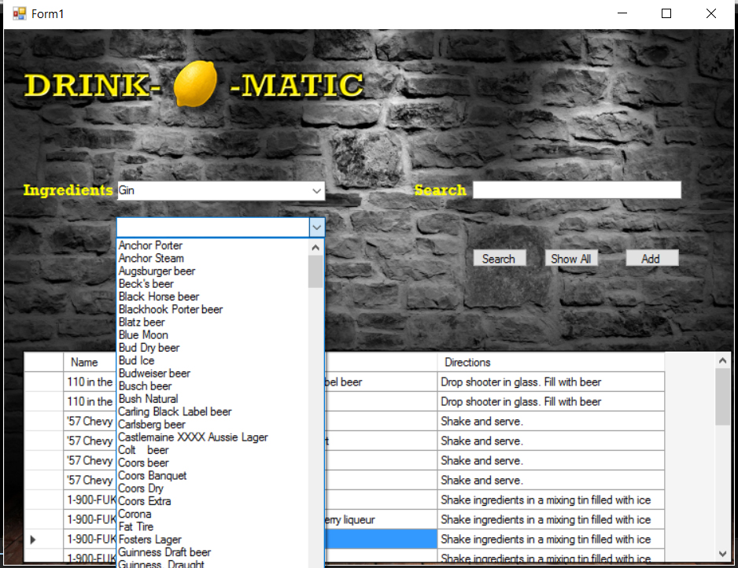

**STEP 3**

**SEARCH**